**Summary**

Ability to design clean and clear interface using various Front End Development tools. Having good understanding of Project Management with strong analytical skills to work indepedently on given problem.

**Skill Highlights**

|  |  |
| --- | --- |
| * Html5 * Css3 * Java script * Bootstrap * Git |  |

Education

Bachelor of computer application: - 2022-23

**c.v.raman University**.

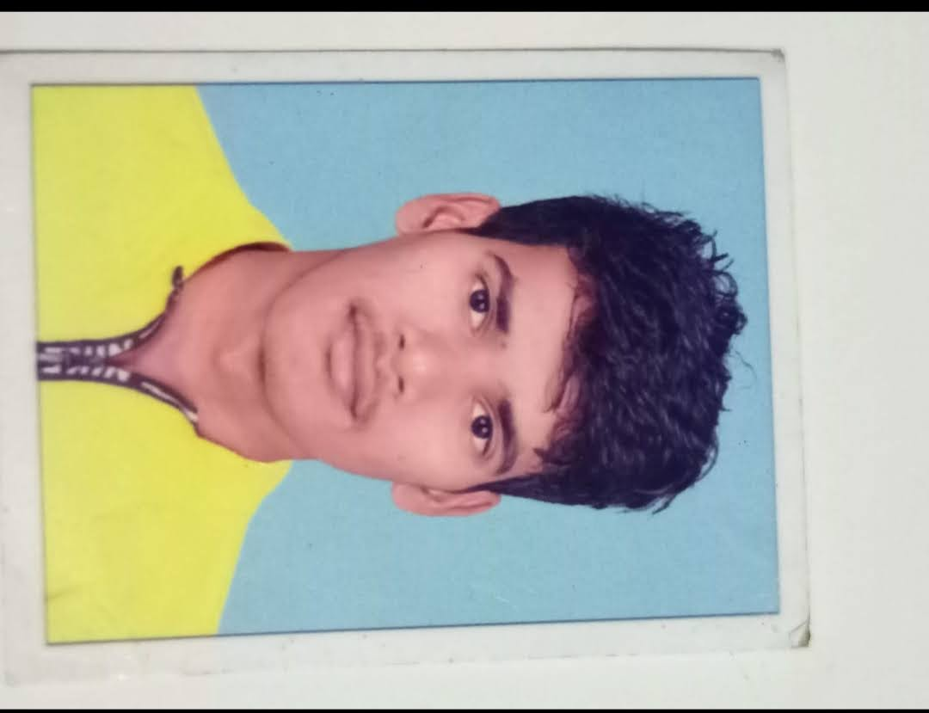

**NIKHIL SAKPAL**

**Contact**

**Address:**

R.N.10 JOHARABAI CHAWL, GAVODEVI ROAD,TEMBIPADA,BHANDUP(W)

**Phone:**

+91 7741044137

**Email:**

nikhilsakpal057@gmail.com

Profile Links

Linkedin :

Github: https://github.com/nis057/myweb.git